ASSIGNMENT-1

1)
- Tableau is a leading data visualization tool used for data analysis and business intelligence.
- It is one of the best visualization tool used for reporting and analyzing the vast volumes of data
- It needs no prior knowledge to programming, users without relevant experience can easily create visualizations in tableau.
- Tableau supports powerful data discovery and exploratory that enables users to answer important questions in seconds.
2)
Some of the tableau products are listed below:
- Tableau Desktop
- Tableau Public
- Tableau Online
- Tableau Server
- Tableau Reader
- Tableau Mobile

3)
In tableau you can join maximum of 32 tables, it is like just dragging and dropping the tables.

4)
Tableau's native connectors can connect to the following types of data sources.
File Systems such as CSV, Excel, etc.
Relational Systems such as Oracle, Sql Server, DB2, etc.
Cloud Systems such as Windows Azure, Google Big Query, etc.
Other Sources using ODBC.

5 and 6)

Stores overall Revenue is shown in the figure
I used the sub-category in the columns and profits(which is revenue for the company)
In rows.
Then applied filter for the profits to get only the profits and take to ignore all the losses.
So we can the overall revenue(Profits)
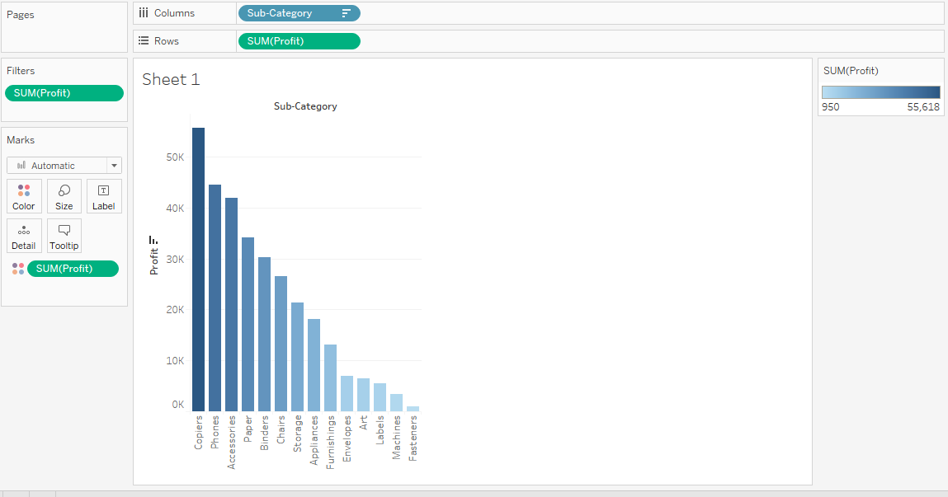

7)
Here I used category in the columns and segment, sales in the rows
Now I used filter option for category and selected furniture and used the same filter option to filter the segment corporate.
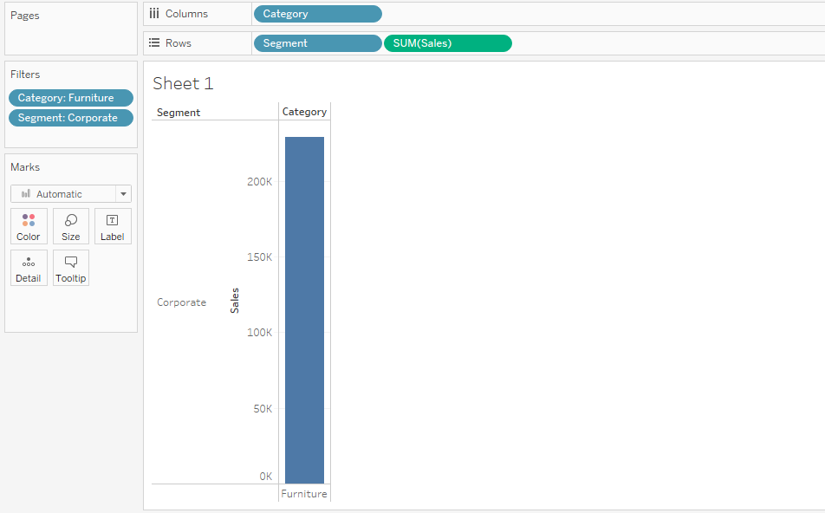

8)
Here We used the Order Id in the columns and Discount in rows and used filter to filter the discount on average and filtered top 50 order id’s and found out the most significant value.
